**DAILY ONLINE ACTIVITIES SUMMARY**

|  |  |  |  |  |  |  |  |  |
| --- | --- | --- | --- | --- | --- | --- | --- | --- |
| **Date:** | **22/06/2020** | | | | | **Name:** | **RITIKA R KULKARNI** | |
| **Sem& Sec** | **4​th​ SEM. & ‘B’ SEC.** | | | | | **USN:** | **4AL19CS403** | |
| **Online Test Summary** | | | | | | | | |
| **Subject** | | **--** | | | | | | |
| **Max. Marks** | | **--** | | **Score** | | | **--** | |
| **Certification Course Summary** | | | | | | | | |
| **Course** | **BLOCKCHAIN ESSENTIAL** | | | | | | | |
| **Certificate Provider** | | | **Cognitive class** | | **Duration** | | | **5 Hrs.** |
| **Coding Challenges** | | | | | | | | |
| **Problem Statement:**   1. **Given three numbers x, y and p, compute (xy) % p.**   **Input: x = 2, y = 3, p = 5**  **Output: 3**  **Explanation: 2^3 % 5 = 8 % 5 = 3.** | | | | | | | | |
| **Status: Executed.** | | | | | | | | |
| **Uploaded the report in Github** | | | | | **Yes** | | | |
| **If yes Repository name** | | | | | <https://github.com/ritikakulkarni> | | | |
| **Uploaded the report in slack** | | | | | **Yes** | | | |

**Online Certification course Summary​: Yesterday, I went through new Certification Course Blockchain essential and necessary condition and Today, I went through IBM & Blockchain and Vehicle demo there are few modules I finished it and I got certificate.**

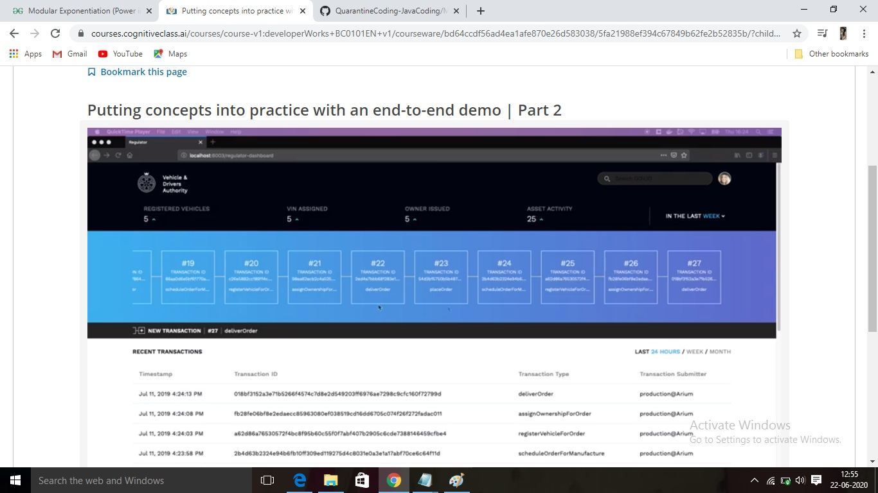

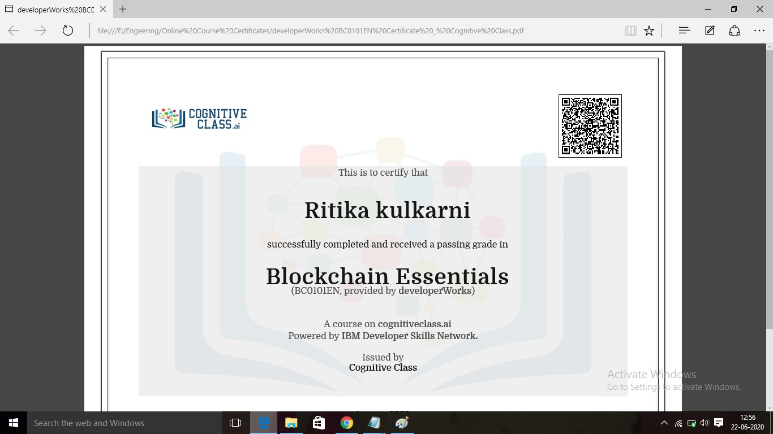

**Online Coding Summary​:Today I received three programs from Shilpa mam CSE Dept.. I have written one program and uploaded it to my Github repository. This is my repository snapshot. I have uploaded the frequency program.**

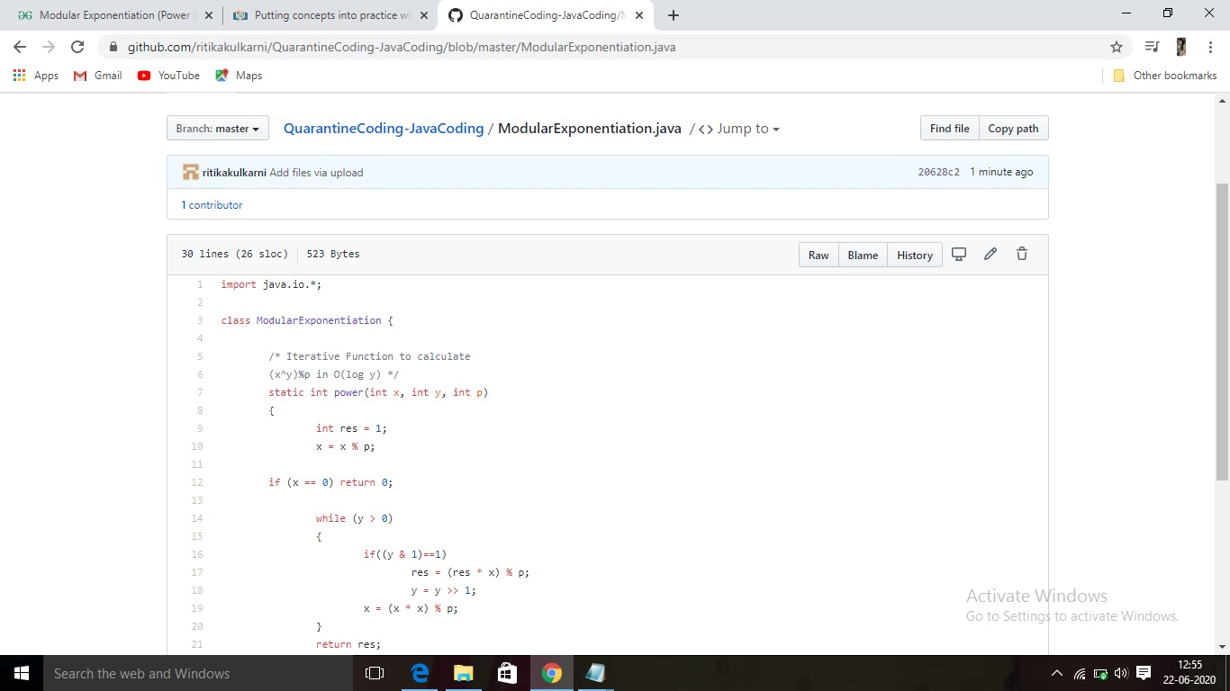

**Thank you**